
Nitte Meenakshi Institute of Technology

Yelahanka, Bangalore- 560064, Karnataka- India.
An Autonomous Institution with A⁺ Grade by NAAC UGC, Approved by VTU, UGC, AICTE, Govt. of India.

Department of Electronics and Communication Engineering
AY: 2025-2026 (EVEN Semester)

Report submitted on the fulfillment of INTERNSHIP

DATA ENGINEERING
WEEKLY REPORT

Submitted By

BHumika K.R 1NT22EC036

Under the Guidance of

Mr. Amruth Ashok Gadag | Mrs. Prajna K B | Dr.Anupama Sindgi
Associate Professor | Assistant Professor | Assistant Professor

Department of Electronics and Communication Engineering Nitte Meenakshi Institute of Technology,
Yelahanka, Bangalore-560064, Karnataka, India.

Contents
Page No. 1.Introduction to Python Programming 1
- Library Functions 2
Numpy and Matplotlib 2
Seaborn 9
IPYWidgets 10
Pandas 11
Streamlit 14
- Introduction to Power BI 15
- Building Enterprise Analytics Dashbord with Real-time Data Streaming 16
Project Overview 16
Importing Dataset 16
Dataset Columns and Attributes 17
Import Excel File into Power BI 18
Data Modelling and Relationships 18
Create a New Table 19
Visualization and Reports 20
Publishing the report to Power bi Server 23
Implementing steps 24
- Dashboard in a Day by Microsoft Learn 25
- Basics of SQL 28
- Conclusion 31
CHAPTER 1

INTRODUCTION TO PYTHON PROGRAMMING
As part of my data engineering internship, my initial task focused on gaining a solid foundation in Python programming and computing environments through hands-on practice with both Linux and Windows terminals. This phase aimed to strengthen my understanding of how Python operates at a fundamental level without relying on external libraries or packages, thereby deepening my knowledge of the languageʼs core capabilities.
Python is an interpreted, high-level programming language well known for its simplicity, readability, and versatility. It is widely used in data engineering for data manipulation, automation, and workflow orchestration. In this introductory module, I worked directly in terminal environments to execute Python scripts, which helped me learn how the interpreter processes code and how command-line interfaces can simplify development and testing workflows.
Using the Linux terminal, I explored commands such as ls, cd to manage files and directories effectively. Running Python scripts using python3 filename.py allowed me to understand the execution process and system interactions at a lower level. The Linux environment also encouraged the use of shell scripting principles, permissions handling, and redirection operators to manage input and output data. These skills are essential for data engineers who often work in production servers or cloud-based Linux systems.
On the Windows terminal (Command Prompt and PowerShell), I performed similar tasks such as navigating directories, creating files, and running scripts. Working across both operating systems helped me appreciate their command differences and interoperability. This cross platform experience is valuable because real-world data pipelines often run on hybrid environments combining Windows-based tools with Linux-based servers.Regarding programming practice, I was restricted from using any external Python packages like NumPy or Pandas. Instead, I relied solely on Pythonʼs built-in functions and standard library modules to solve problems. I implemented simple programs for arithmetic operations, string manipulation, conditional branching, and file I/O operations. This approach helped reinforce my grasp of control structures, loops, data types, and error handling in pure Python.
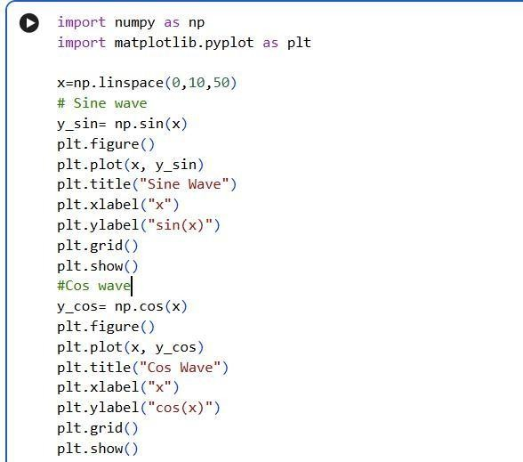
CHAPTER 2

LIBRARY FUNCTIONS

NUMPY AND MATPLOTLIB
NumPy forms the foundation for numerical computing in Python. It supports high- performance array operations and mathematical computations. I practiced creating arrays using numpy.array() and performing vectorized operations, which are faster than conventional Python loops. I also used NumPy for calculating statistical measures such as mean, median, and standard deviation—operations essential for preprocessing data before analysis or visualization.
Matplotlib is a fundamental plotting library that allows users to create static, interactive, and publication-quality graphs. Using functions like plot(), bar() I visualized data distributions and trends. Configuring titles, legends, and axes labels helped me make data more interpretable, which is important for data-driven decision-making.

#PLOTTING SINE WAVE AND COS WAVE
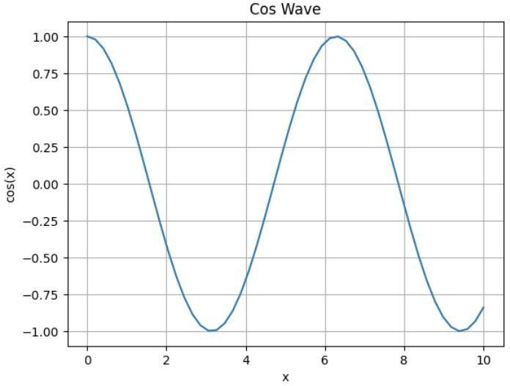
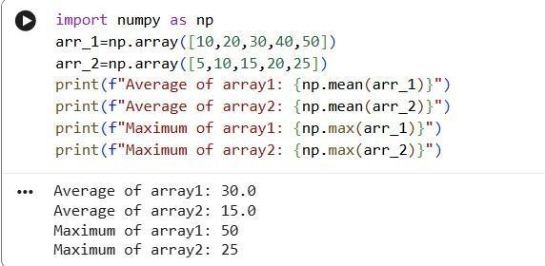


#PRINTING ARRAY
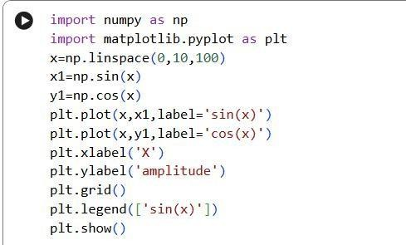
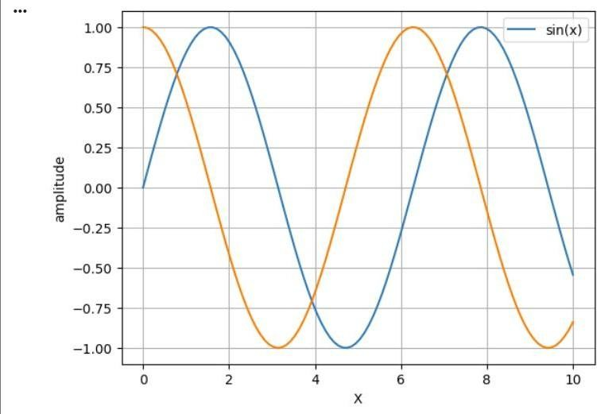
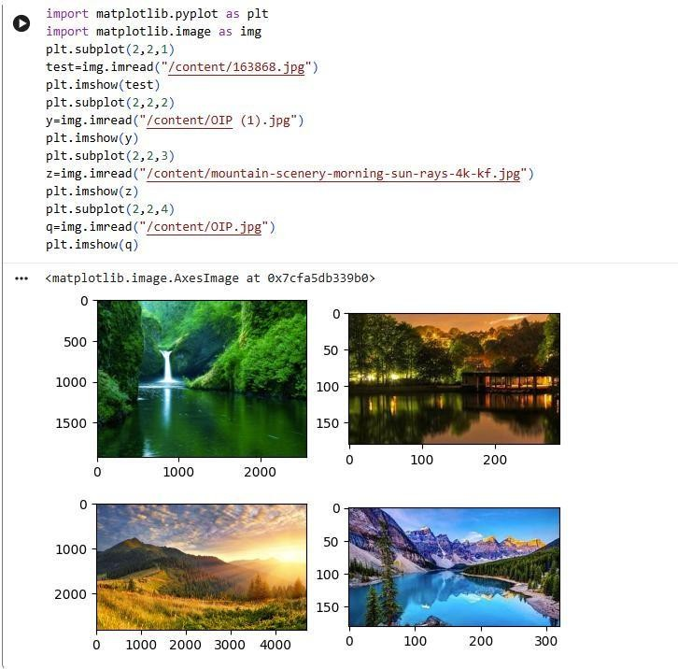
#PLOTTING IN A SINGLE GRAPH

#PLOTTING IMAGES
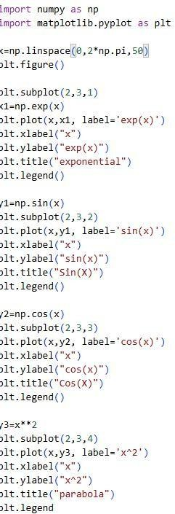
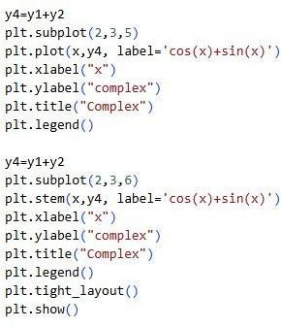
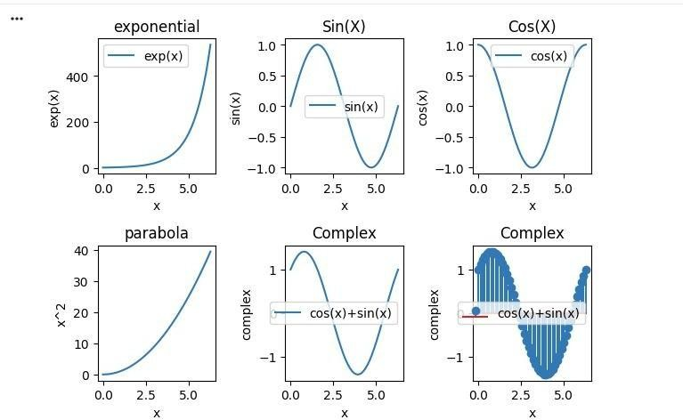
#PLOTTING USING SUBPLOT

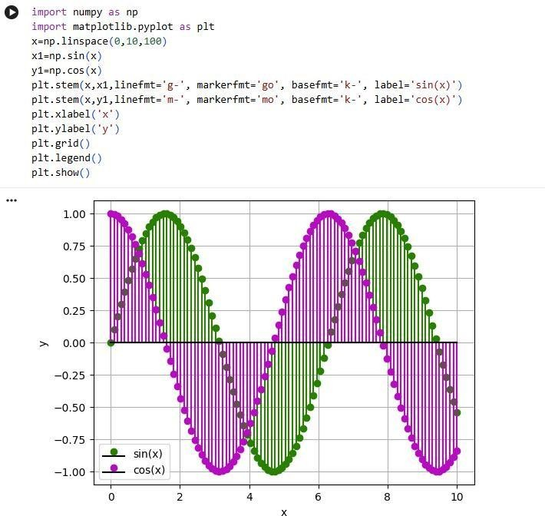
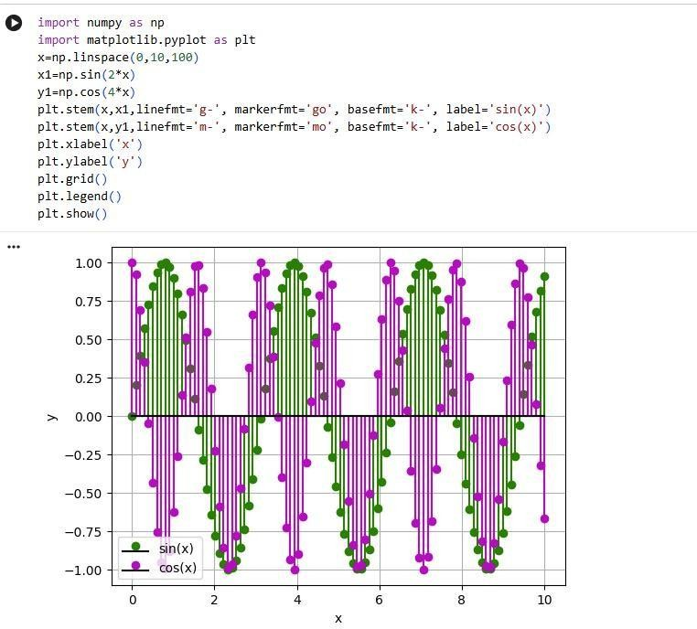
#PLOTTING USING STEM

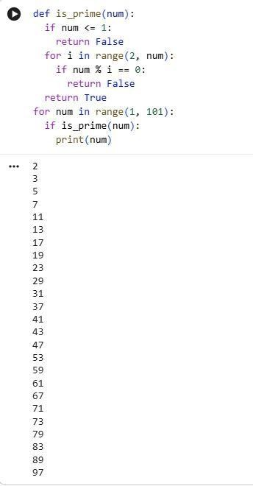
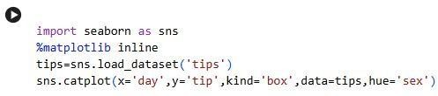
#PRINTING PRIME NUMBERS WITHIN 1-100

SEABORN
Built on top of Matplotlib, Seaborn simplifies statistical data visualization with aesthetic and informative graphics. I used it for visualizing relationships between variables through heatmaps, pair plots, and boxplots. Seaborn automatically integrates well with Pandas DataFrames, making
it ideal for exploratory data analysis.
We use in built dataset called as tips.
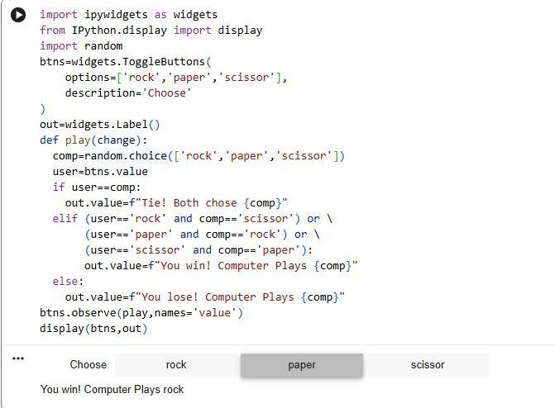
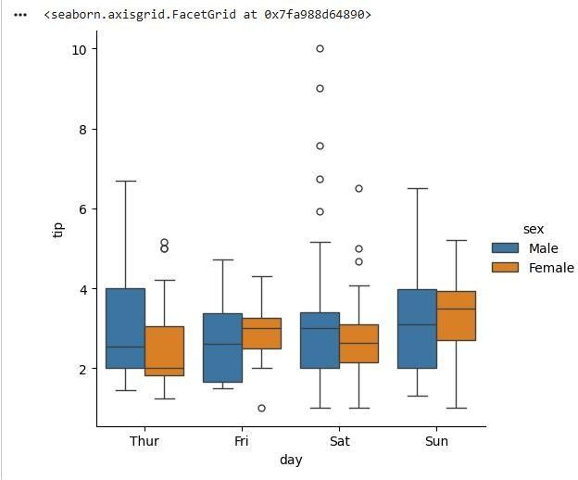

IPYWIDGETS
Widgets enable the creation of interactive controls directly within Colab notebooks. By using sliders, dropdowns, and buttons, I built interactive elements to modify parameters dynamically and visualize outcomes instantly. This enhanced usability and experimentation during analysis.
# PLAYING ROCK,PAPER,SCISSOR
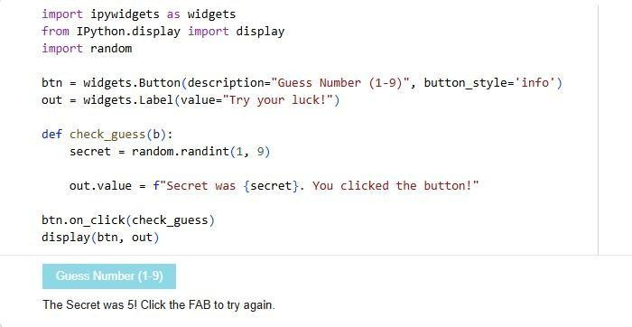
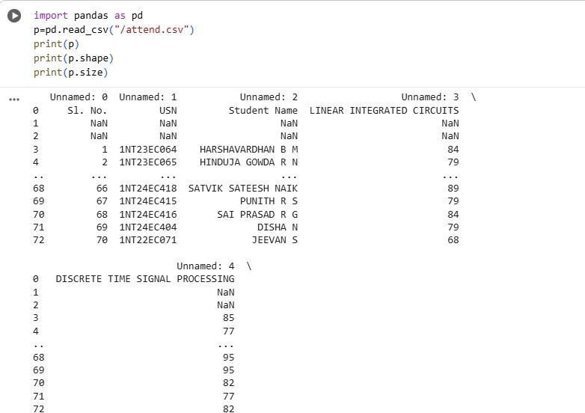
#GUESS YOUR LUCK GAME

PANDAS
Pandas is a powerful open-source library designed for data manipulation and analysis. It introduces data structures like Series and DataFrame, which make it easier to organize and process tabular data. I learned to use functions such as read_csv(), head(), and describe() to load, explore, and summarize datasets. Pandas also provides built-in tools for cleaning data handling missing values, merging datasets, and reshaping tables efficiently.
#IMPORT ATTENDANCE AND MARKS CSV FILE
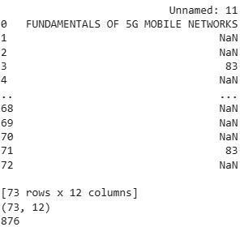
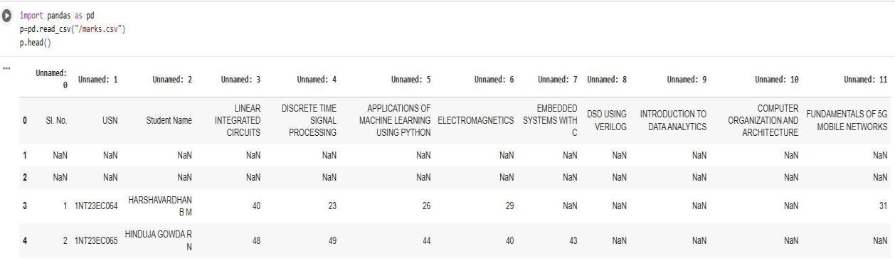
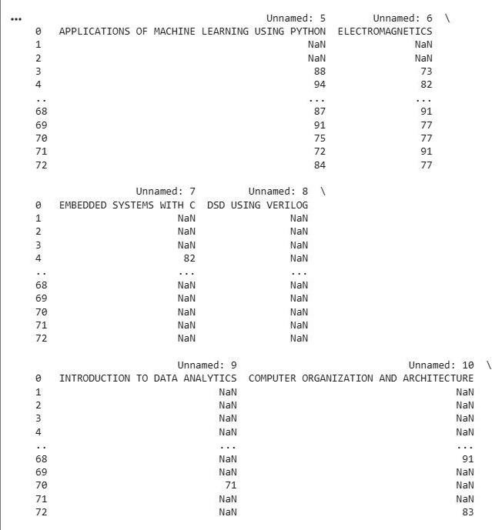

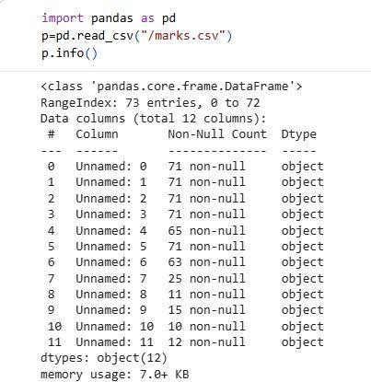
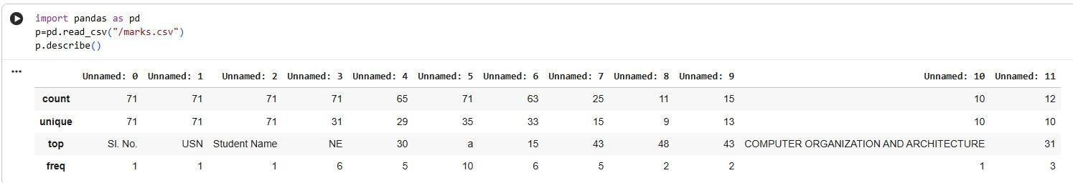
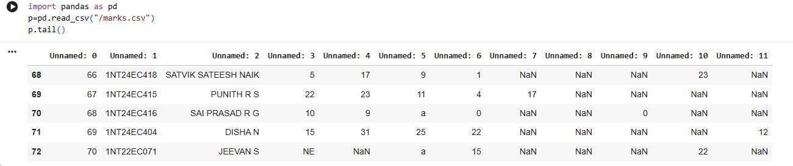

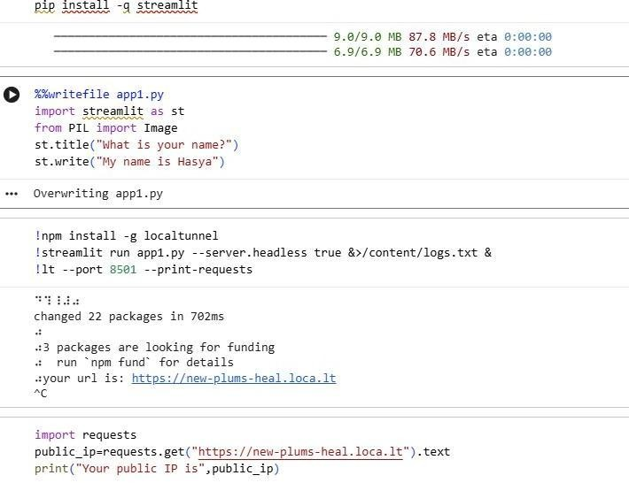
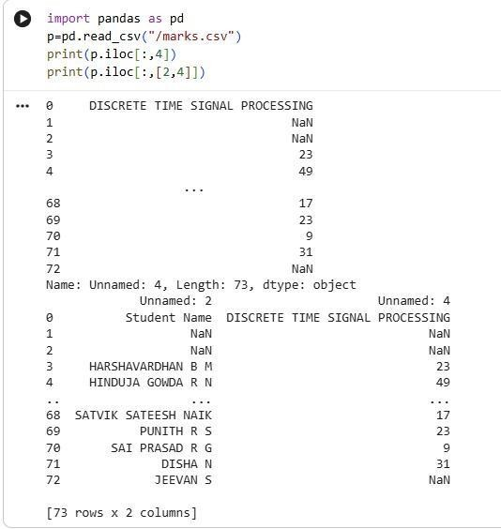

STREAMLIT
Finally, I explored Streamlit, a library for building interactive web applications using Python scripts. I developed simple dashboards that displayed visualizations and user inputs, transforming static analysis into interactive data applications.
CHAPTER 3

INTRODUCTION TO POWER BI

Power BI is a business analytics platform from Microsoft used to connect to data, transform it, and create interactive reports and dashboards for decision-making. It helps organizations turn raw data from multiple sources into visually rich insights that can be easily understood and shared across teams.
One of the key strengths of Power BI is its wide range of data connectivity options, allowing users to import or connect directly to databases, cloud services, Excel files, web data, and many other sources in a single environment. Using Power Query, data can be cleaned, merged, and transformed without writing complex code, which makes it suitable for both technical and non‑technical users. The data model supports relationships between tables, calculated columns, and DAX measures, enabling powerful analytical calculations on top of large datasets.
Power BI also provides rich visualization capabilities, with many built‑in charts, maps, tables, and custom visuals that can be arranged into interactive reports and dashboards. Users can apply filters, slicers, and drill‑down actions to explore data in detail and uncover trends or anomalies quickly. These reports can then be published to the Power BI service, where they are accessible via browser or mobile apps, supporting secure sharing, role‑based access, and collaboration within workspaces.
Another important feature is its support for scheduled and real‑time data refresh, ensuring that dashboards always display up‑to‑date information for monitoring key performance indicators. Organizations can also leverage advanced capabilities such as AI‑driven insights, integration with Excel and other Microsoft 365 tools, and embedding reports into applications and websites. Together, these features make Power BI a comprehensive platform for end‑to‑end business intelligence, from data ingestion to interactive visualization and enterprise‑level sharing.
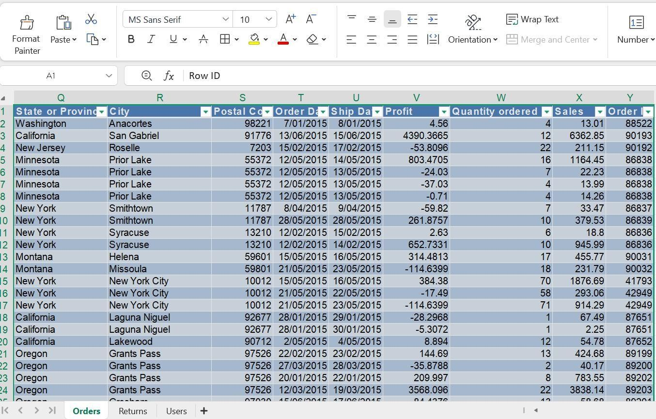
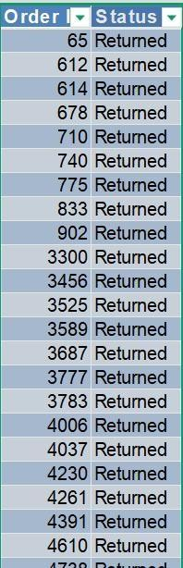
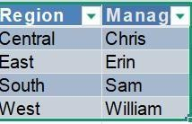
CHAPTER 4

BUILDING ENTERPRISE ANALYTICS DASHBOARDS WITH REAL-TIME DATA STREAMING
  - PROJECT OVERVIEW
Develop a comprehensive business intelligence solution using Power BI that integrates multiple data sources, creates interactive dashboards, and implements real-time data streaming capabilities.
  - IMPORTING DATASET

The Excel file contained a single worksheet with transactional data spanning multiple years (2015 onwards).
  - DATASET COLUMNS AND ATTRIBUTES

Column Name | Data Type | Description
Order ID | Text | Unique identifier for each order
Product Priority | Text | Priority level (Critical, High, Medium, Low, Not Specified)
Discount | Decimal | Discount percentage applied to the order
Unit Price | Currency | Price per unit of the product
Manufacturing Price | Currency | Cost to manufacture the product
Customer ID | Number | Unique identifier for each customer
Customer Name | Text | Full name of the customer
Shipping Mode | Text | Method of shipment (Regular Air, Express Air, Delivery Truck)
Segment | Text | Customer segment (Corporate, Small Business, Consumer, Home Office)
Category | Text | Product category (Office Supplies, Technology, Furniture)
Sub-Category | Text | Detailed product classification (e.g., Binders, Telephones)
Container | Text | Packaging size (Small Box, Large Box, Jumbo Box, Wrap Bag, etc.)
Product Name | Text | Full description of the product
Profit | Currency | Profit amount for the transaction
Country | Text | Country of operation (United States)
Region | Text | Geographic region (East, West, Central, South)
State | Text | State abbreviation or full name
City | Text | City/Location name
Postal Code | Number | ZIP/Postal code
Order Date | Date | Date when order was placed (Excel serial format: 42028, etc.)
Ship Date | Date | Date when order was shipped
Profit (numeric) | Currency | Profit value in numerical format
Quantity | Number | Number of units ordered
Sales | Currency | Total sales amount for the transaction

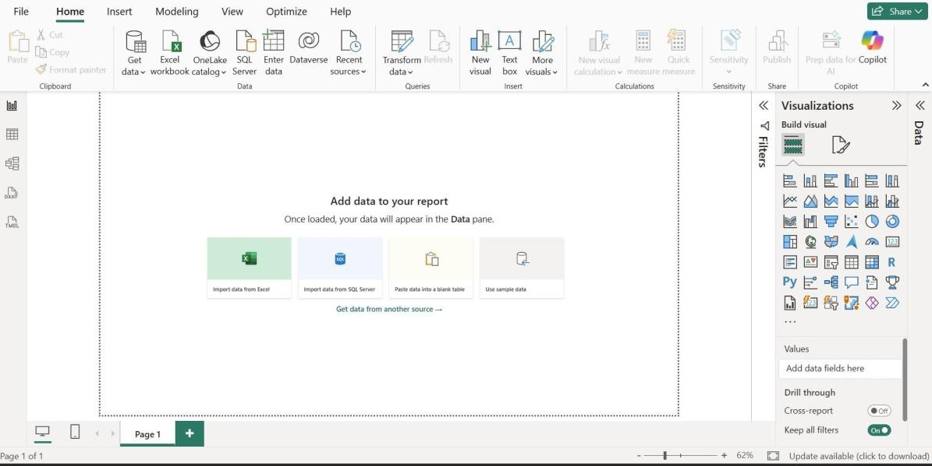
  - IMPORT EXCEL FILE INTO POWER BI

Step 1: Launch Power BI Desktop

    - Opened Power BI Desktop application
    - Started a new blank project

Step 2: Access Data Connector
    - Clicked on "Get Data" in the Home ribbon
    - Selected "Excel" from the data source options

Step 3: Browse and Select File
    - Navigated to the file location containing S01-Welcome.SuperStoreUS1-2015.xlsx
    - Selected the Excel workbook
    - Clicked "Open" to establish connection

Step 4: Preview Data
    - Power BI displayed the available tables/sheets in the Excel file
    - Selected the main data sheet containing sales transactions
    - Reviewed the data preview to confirm correct table selection

Step 5: Load Data
    - Clicked "Load" to import the entire dataset into Power BI
    - Alternatively, clicked "Transform Data" to access Power Query for initial transformations.

  - DATA MODELLING AND RELATIONSHIPS
Implemented a Star Schema design with:
    - Fact Table: Sales (transactional data)
    - Dimension Tables: Date, Customer, Product, Region
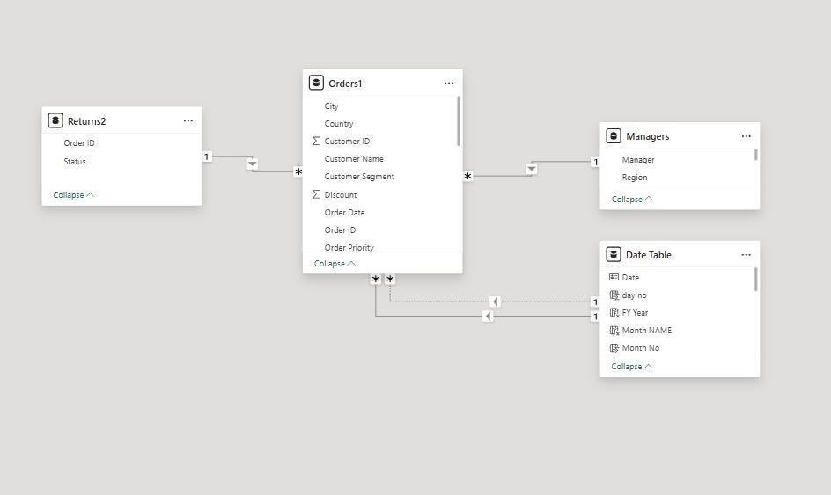

Relationship | From Table | To Table | Type | Cardinality
Product Lookup | Sales | Product | One-to-Many | 1:*
Customer Lookup | Sales | Customer | One-to-Many | 1:*
Date Lookup | Sales | Date | One-to-Many | 1:*
Region Lookup | Customer | Region | One-to-Many | 1:*

  - CREATE A NEW TABLE
A custom date table was created using DAX to enable time-based analysis:

Column Name | DAX Formula
Year | YEAR('Date Table'[Date])
Quarter No | QUARTER('Date Table'[Date])
Month No | MONTH('Date Table'[Date])
Week No | WEEKNUM('Date Table'[Date])
Day No | WEEKDAY('Date Table'[Date])
Month Name | FORMAT('Date Table'[Date],"mmmm")

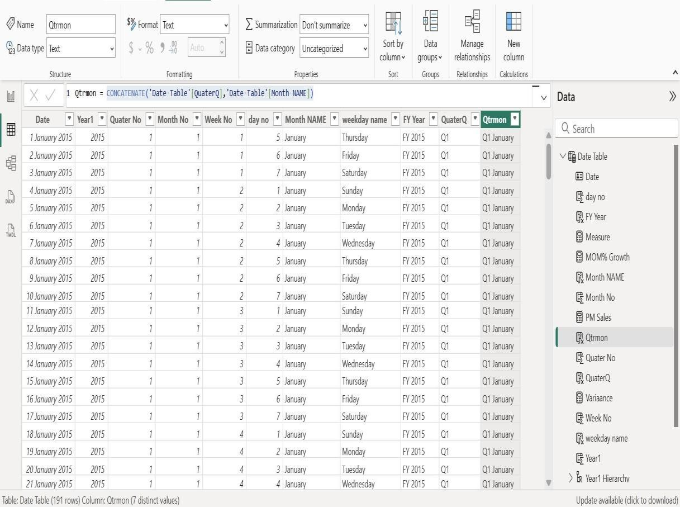
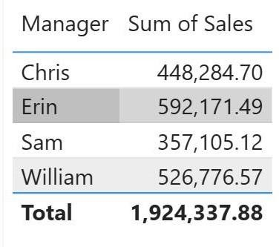

Weekday Name | FORMAT('Date Table'[Date],"DDDD")
FY Year | "FY" & " " & 'Date Table'[Year1]
Quarter Q | FORMAT('Date Table'[Date],"\Qq ")
Quarter Month | CONCATENATE('Date Table'[QuaterQ],'Date Table'[Month NAME])

  - VISUALIZATIONS AND REPORTS

Selected appropriate visualization types based on data and insights required:

- TABLE
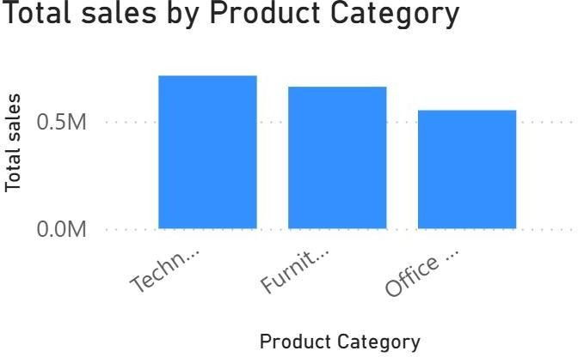
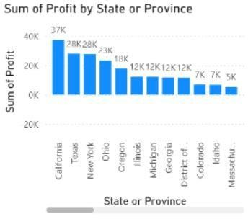
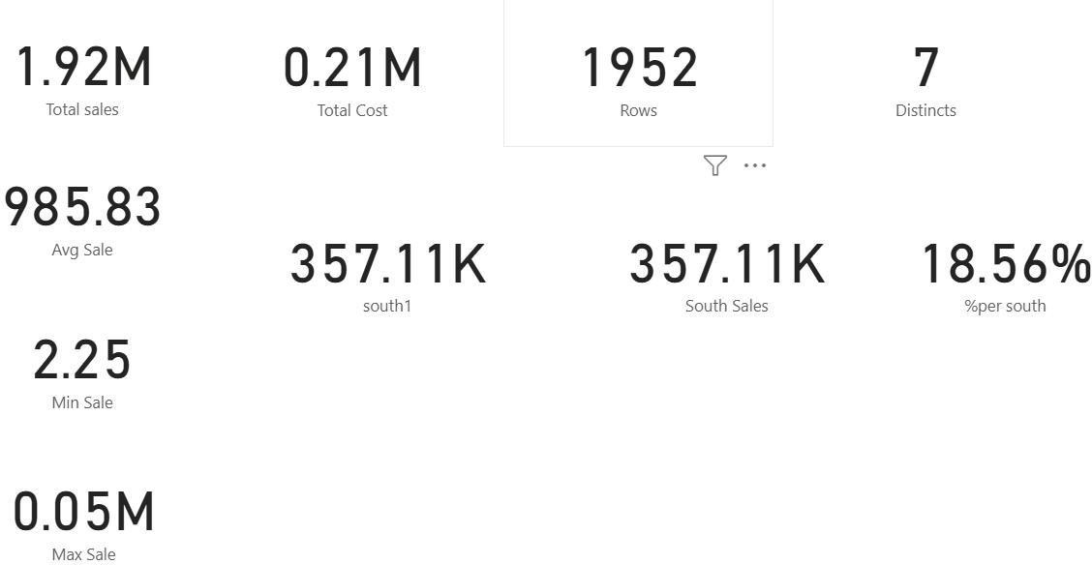
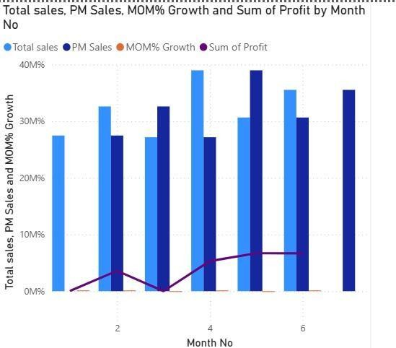
- STACKED COLUMN CHART

- CARD

- LINE AND CLUSTERED COLUMN CHART
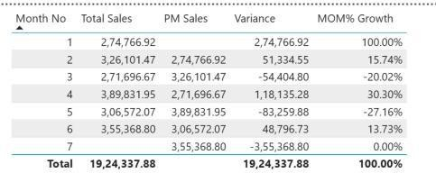
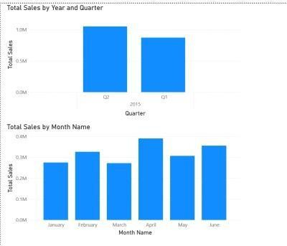
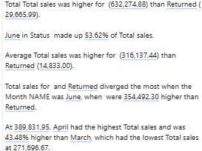
- TABLE WITH PROFIT RATIO

- CLUSTERED COLUMN CHART

- NARRATIVE
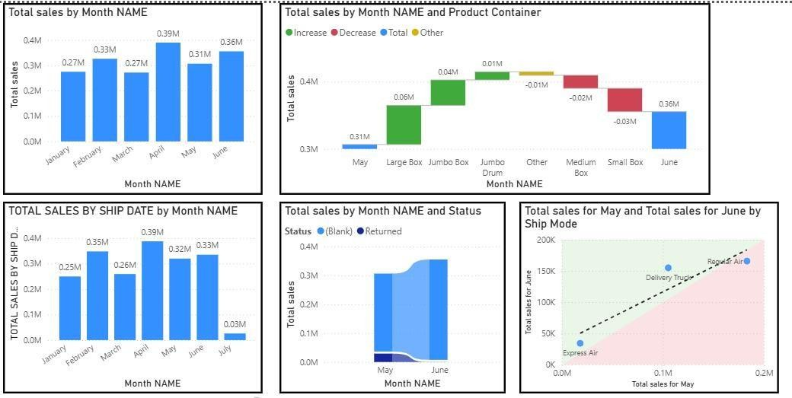
- REPORT WITH PROPER BORDER ALIGNMET

  - PUBLISHING THE REPORT TO POWER BI SERVER

Step 1: Prepare for Publishing

    - Reviewed all reports and dashboards for accuracy
    - Verified data connections and credentials
    - Optimized performance of queries

Step 2: Configure Power BI Service Settings

    - Signed into Power BI Service (app.powerbi.com)
    - Created a new workspace: "DAY 3"
    - Set appropriate access permissions

Step 3: Publish Report

    - In Power BI Desktop: File → Publish
    - Selected target workspace: "DAY 3"
    - Confirmed publication of all report pages and datasets

Step 4: Configure Dataset Settings

    - Configured data source credentials
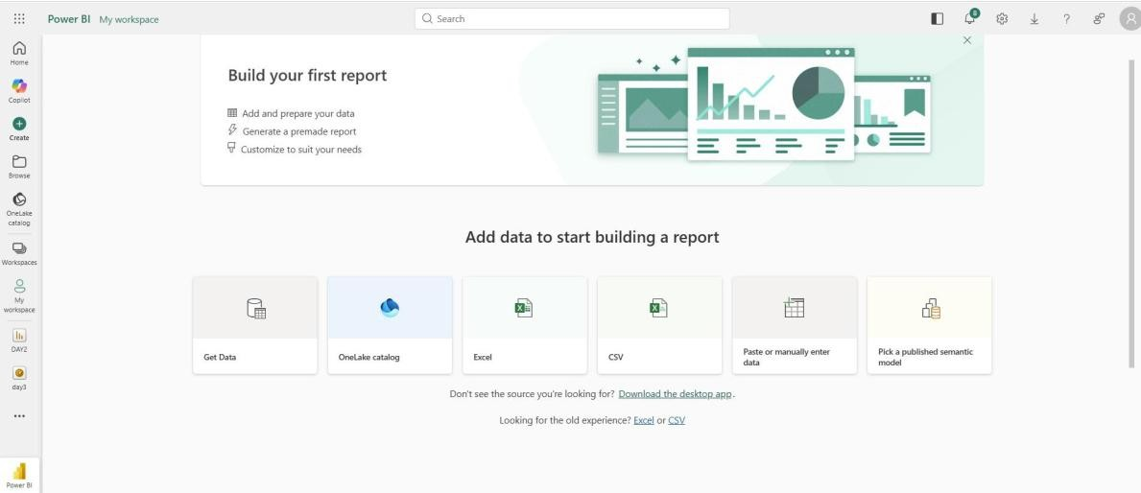
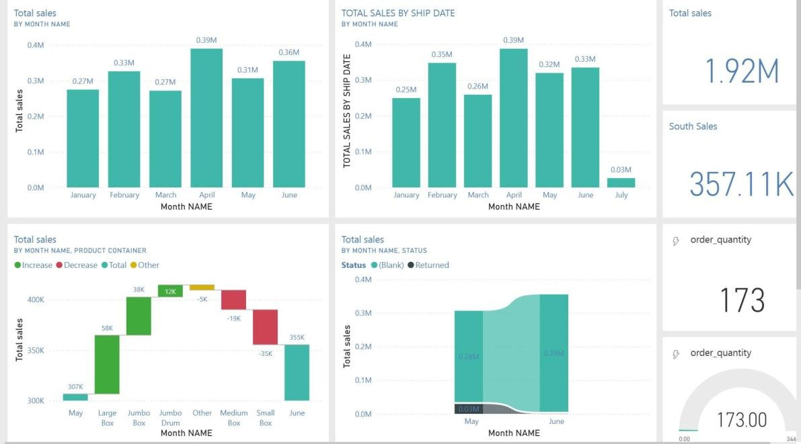
    - Enabled gateway connectivity for on-premises data.

Implementation Steps
Step 1: Create PubNub Account

    - Registered at pubnub.com
    - Created a new app and configured keys
    - Obtained Publish and Subscribe keys

Step 2: Set Up Streaming Dataset in Power BI

    - In Power BI Service: Create → Streaming dataset
    - Selected "API" as data source
    - Defined schema with columns
CHAPTER 5

DASHBOARD IN A DAY BY MICROSOFT LEARN

      - Program Overview: One-day intensive Microsoft Learn training to create interactive business dashboards using Power BI Desktop, designed for beginners to intermediate users needing practical BI skills.

      - Dashboard Fundamentals: Learned that dashboards provide quick at-a-glance summaries with key metrics, unlike detailed reports; focused on visual hierarchy, color theory, and design principles to communicate insights effectively.

      - Power BI Interface: Mastered Power BI Desktop interface with tabs (Home, Insert, Data, Modeling, View) and working panes (Data, Visualizations, Filters) across three views: Report, Data, and Model.

      - Data Connectivity: Connected to multiple data sources (Excel, SQL Server, CSV, web) using import/live query modes; configured refresh schedules and managed credentials securely for real-time data access.

      - Data Transformation: Used Power Query to clean, transform, and prepare data by removing duplicates, splitting/merging columns, filtering rows, and creating helper columns; optimized queries for performance.

      - Data Modeling: Built star schema with fact table (Sales) and dimension tables (Customers, Products, Dates, Regions); established one-to-many relationships and created hierarchies for drill-down capabilities.

      - Visualizations & Charts: Created 10+ chart types (bar, line, pie, scatter, map, KPI, gauge, waterfall) with corporate branding colors, data labels, and customized formatting for clear data storytelling.

      - DAX Calculations: Wrote advanced formulas using aggregation (SUM, AVERAGE), time intelligence (YTD, PREVIOUSMONTH), conditional logic (IF, SWITCH), and filtering (CALCULATE, RANKX) for complex business metrics.
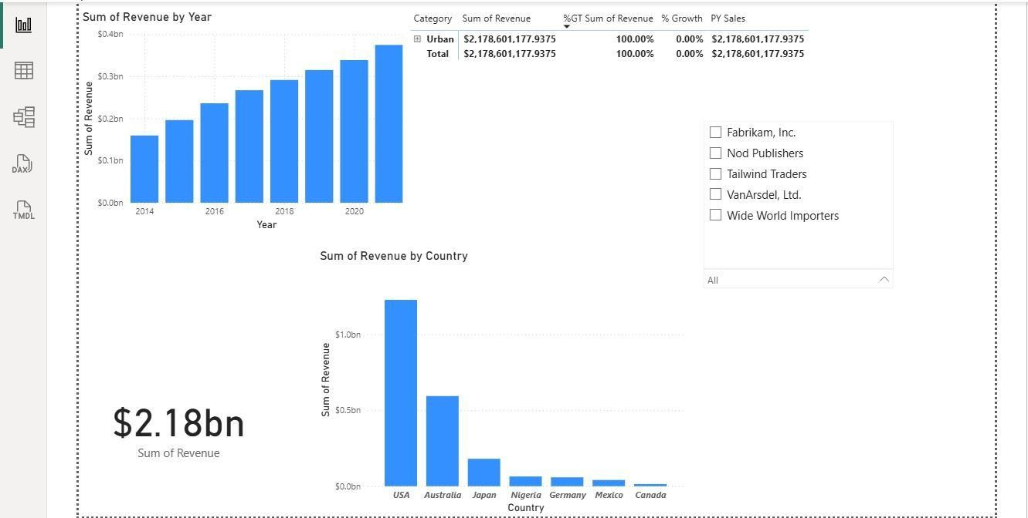
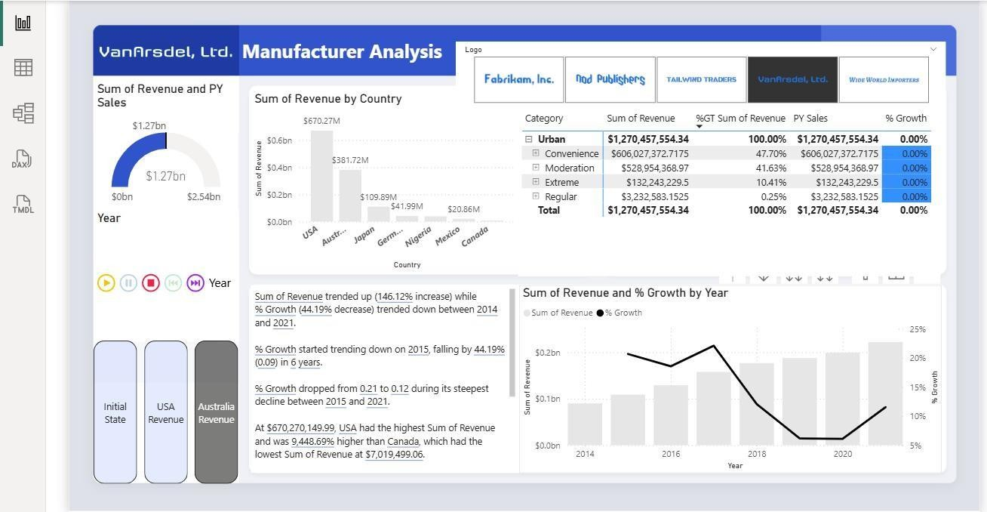
      - Interactive Dashboard: Implemented slicers for date/region filtering, cross-filtering between visuals, drill-down hierarchies, bookmarks for navigation, and toggle buttons; completed a full Sales Performance Dashboard in 8 hours.

  - DIFFERENT VISUALIZATION

  - ANALYSIS BY MANUFACTURER
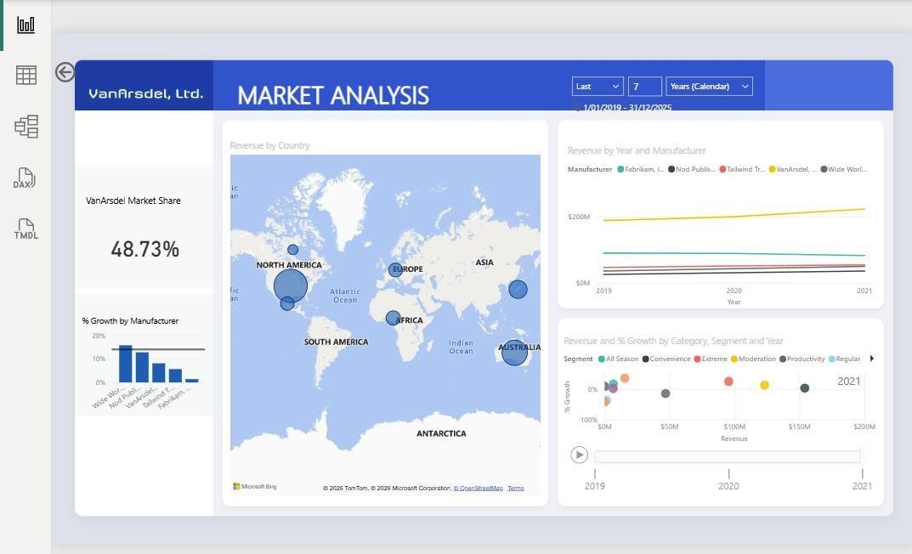
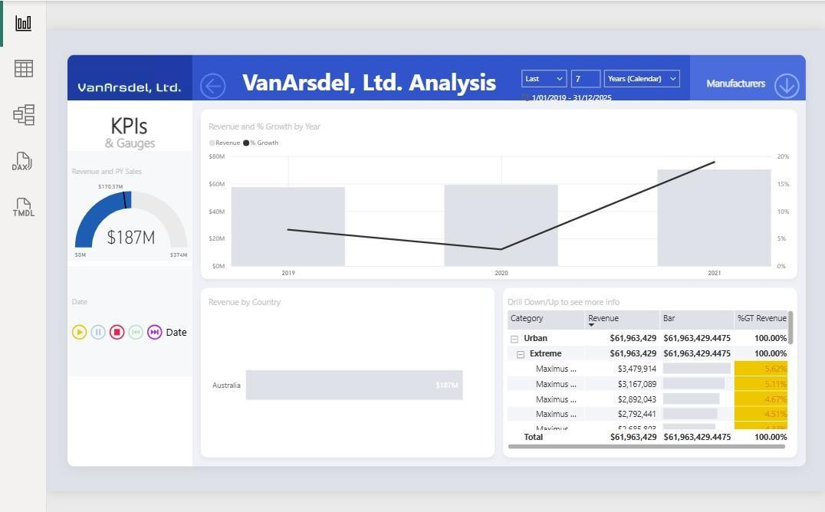
  - MARKET ANALYSIS

  - MANUFACTURER ANALYSIS
Chapter 6

BASICS OF SQL

SQL, or Structured Query Language, is a standardized programming language for interacting with relational databases.
It handles data organization, storage, and retrieval in tables with rows and column SELECT
    - Specifies which columns or expressions appear in the result set.
    - Can return all columns or only selected columns.
    - Supports calculated expressions and built‑in functions.
    - Can remove duplicates and rename columns using options like DISTINCT and aliases.
FROM

    - Identifies the table or tables that provide the data.
    - Allows combining multiple tables using joins.
    - Accepts views, subqueries, and other row‑producing sources.
    - Always works together with a SELECT clause in a query. WHERE
    - Filters rows coming from the FROM source.
    - Keeps only rows where the condition evaluates to true.
    - Uses comparison, logical, pattern, and set operators.
    - Is optional; if omitted, all rows from the source are returned.

Introduction to Relational Integrity

The primary goal of a relational database is to maintain "Single Source of Truth." This is achieved through constraints that prevent human error and logical inconsistencies.

Primary Key (PK) & Entity Integrity
A Primary Key ensures that every record is unique and identifiable. During the experiment, we observed:
      - Uniqueness: Attempting to insert a duplicate unique identifier (USN) resulted in a Duplicate Entry error.
      - Non-Nullability: The system rejected records without a PK, ensuring no "ghost" records exist.

Foreign Key (FK) & Referential Integrity
Foreign keys create the "glue" between tables. We tested two primary behaviors:
- Restrict (Default): The database blocked the deletion of a student if they had existing marks, preventing "orphaned" data.
- Cascade: In later stages, we configured the system to automatically delete child records when a parent was removed, maintaining a clean database state.

Advanced Data Manipulation & Retrieval
Efficient data management requires more than simple storage; it requires the ability to reconstruct complex relationships via Joins and Aggregate functions.

The Logic of Joins
We implemented several Join types to combine data from the Student, Department, and Course tables:
      - Inner Join: Matched only the students who belong to a department.
      - Left Join: Ensured that even students not yet assigned to a department appeared in the report.
      - Self Join: Used to compare rows within the same table, such as finding students in the same age group.

Aggregation and Analytics
By using functions like MAX(), MIN(), and AVG(), we transformed raw data into insights, such
as identifying the highest marks in a course or the average age of a department’s student body.

Data Abstraction and Automation
To enhance user experience and maintain logs, we utilized Views and Triggers.

Virtual Tables (Views)
A View (StudentInfo) was created to hide the complexity of multiple Joins. Users can query the
View as a single table, which enhances security by hiding sensitive columns (like internal IDs) while providing necessary information.

Automated Auditing (Triggers)
To track changes in student performance, we implemented an AFTER UPDATE trigger.
      - Mechanism: Whenever a grade is modified, the trigger automatically pushes the Old_Value, New_Value, and Timestamp into a Marks_Audit table.
      - Benefit: This provides a non-repudiable log of all changes, crucial for academic and financial integrity.

Database Security & User Management
Security in DBMS is managed through Role-Based Access Control (RBAC). This prevents unauthorized data modification while allowing users to perform their specific duties.

Implementation of Roles
We defined two distinct roles to simulate a university hierarchy:
- Admin Role: Granted ALL PRIVILEGES to manage schema changes and user accounts.
- DataEntry Role: Restricted to INSERT and SELECT. This user can add new students but cannot delete existing records or drop tables.
    - Security Verification Table
Operation | Admin User | Data Entry User | Security Logic
Drop Table | Permitted | Denied | Only Admins should alter structure.
Delete Row | Permitted | Denied | Prevents accidental/malicious data loss.
Insert Row | Permitted | Permitted | Essential for daily operations.

Chapter 7
CONCLUSION
The integration of Python programming, SQL database management, and Power BI analytics forms a cohesive framework that addresses the complexities of the modern data landscape. This curriculum demonstrates that data proficiency is not merely about using a single tool, but about mastering the synergy between data retrieval, computational processing, and executive visualization.
SQL and Database Governance provide the essential bedrock for this ecosystem. As demonstrated through the experiments on Referential Integrity and User Management, a database is only as valuable as its reliability. By enforcing primary and foreign key constraints, we ensure "Entity Integrity," preventing the fragmentation of information. Furthermore, the implementation of Triggers and Views illustrates the shift toward automation and data abstraction—essential components for maintaining "Single Source of Truth" in high-volume environments.
Building upon this foundation, Python serves as the versatile engine for advanced manipulation. While SQL handles structured storage, Python’s library ecosystem—specifically Pandas, NumPy, and Seaborn—allows for sophisticated exploratory data analysis and statistical modeling. The use of IPYWidgets and Streamlit further bridges the gap between static analysis and interactive application development, enabling analysts to create bespoke tools tailored to specific organizational needs.
The final transition into Power BI represents the conversion of raw data into "Actionable Intelligence." Through Data Modeling and Real-time Data Streaming, the curriculum highlights the importance of accessibility. An enterprise dashboard serves as the interface where complex SQL queries and Python scripts are distilled into intuitive visual narratives. The ability to publish these insights to a Power BI Server ensures that data-driven decision-making is democratized across the enterprise.
In conclusion, the convergence of these technologies ensures a robust data lifecycle: SQL manages the integrity, Python provides the analytical depth, and Power BI delivers the strategic clarity.

